Set Voltage =1.2V, Reset Voltage =-1.5V

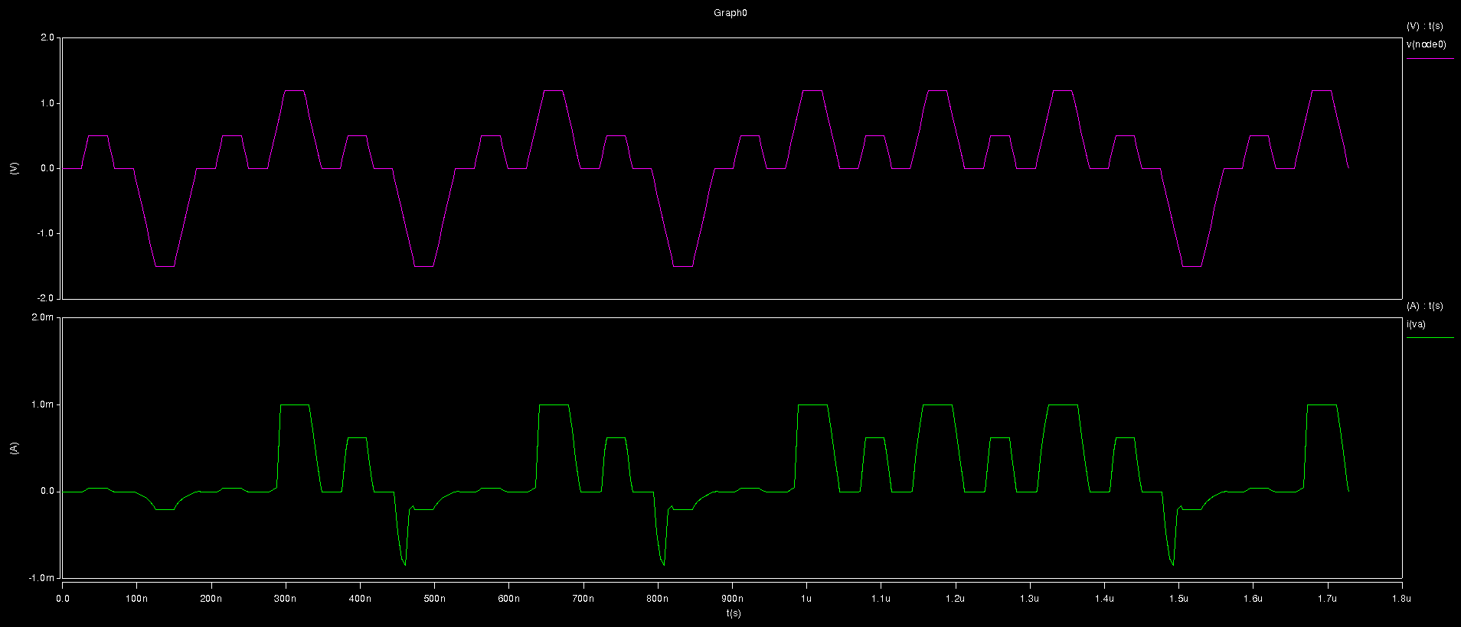

Set Voltage =1.1V, Reset Voltage =-1.5V

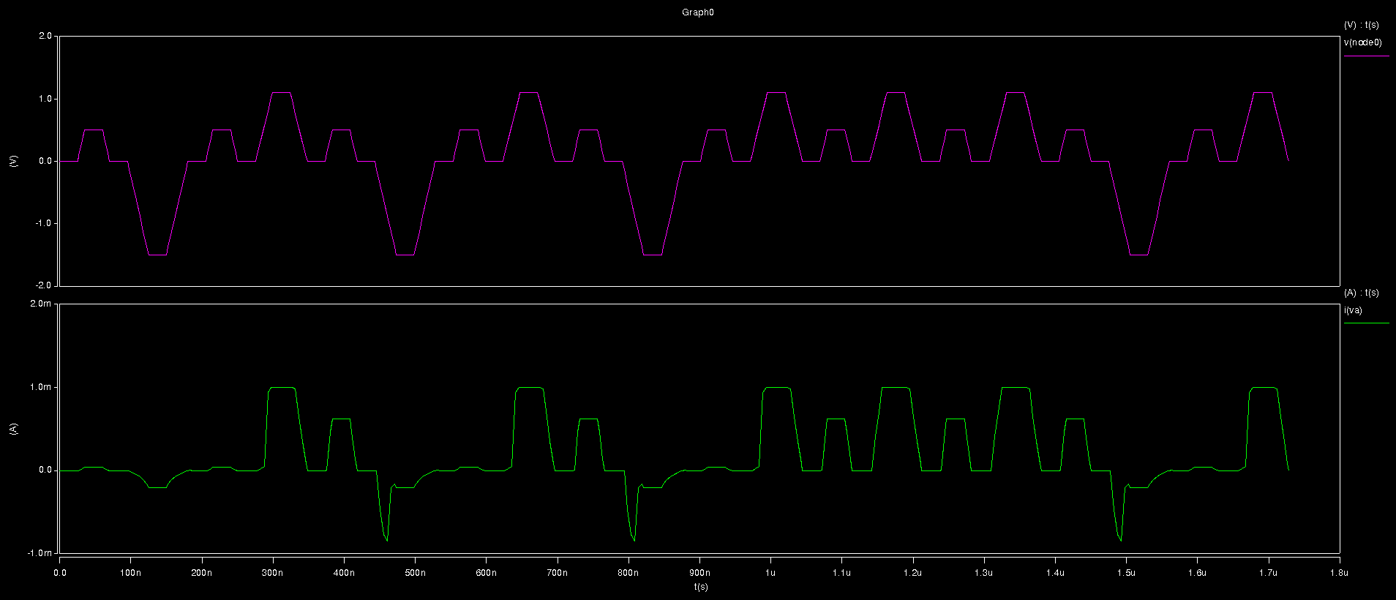

Set Voltage =1V, Reset Voltage =-1.5V

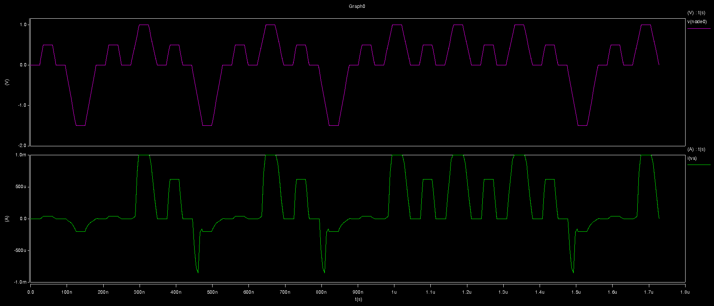

Set Voltage =0.9V, Reset Voltage =-1.5V

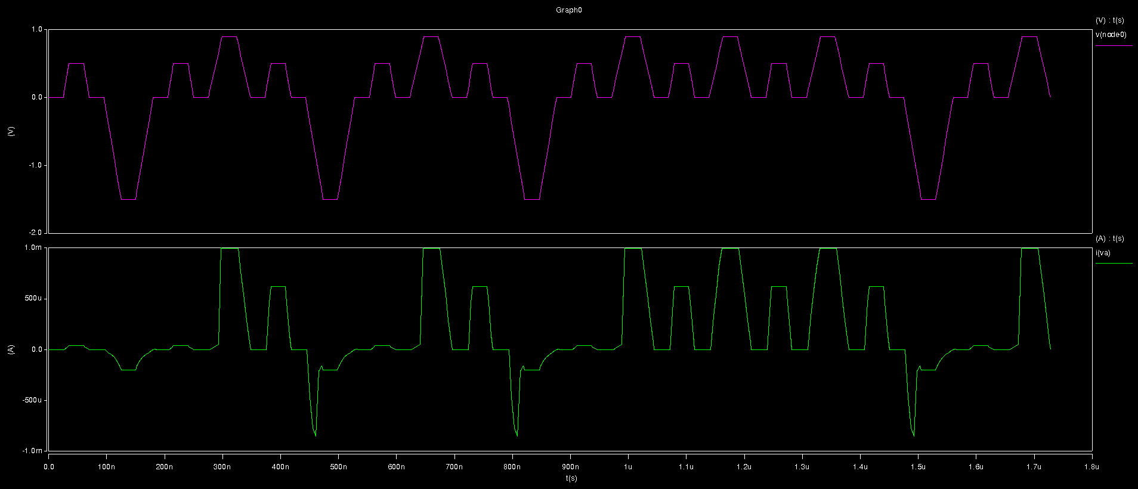

Set Voltage =0.84V, Reset Voltage =-1.5V

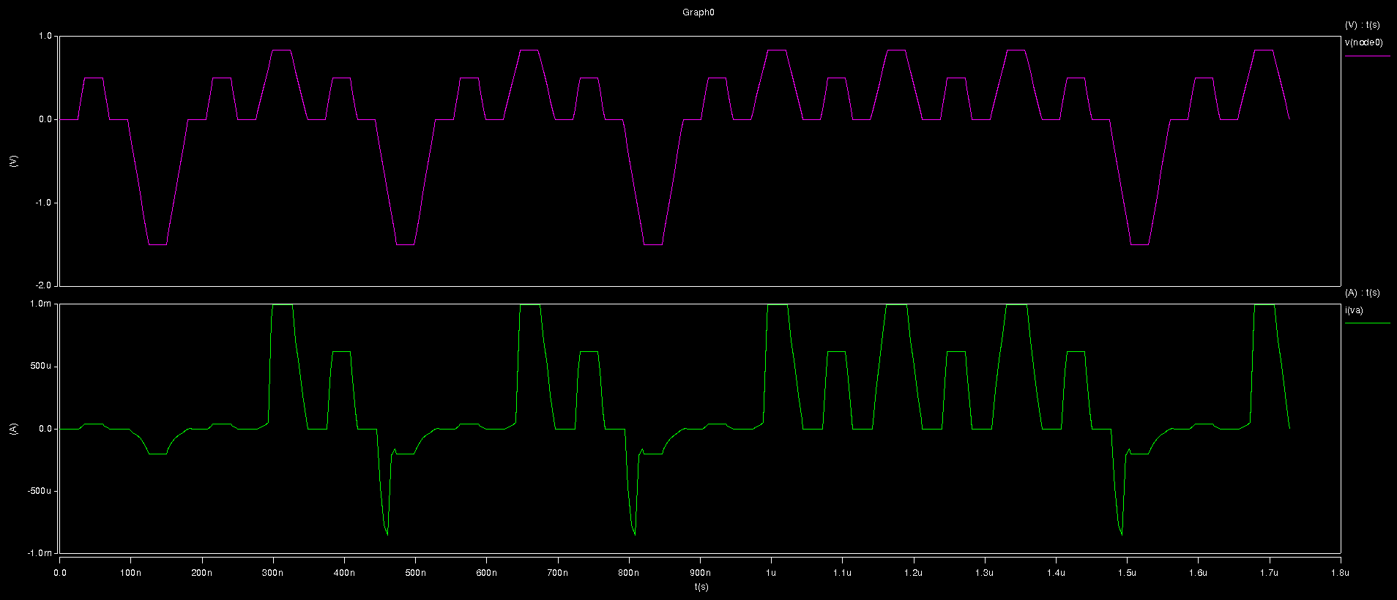

Set Voltage =0.83V, Reset Voltage =-1.5V

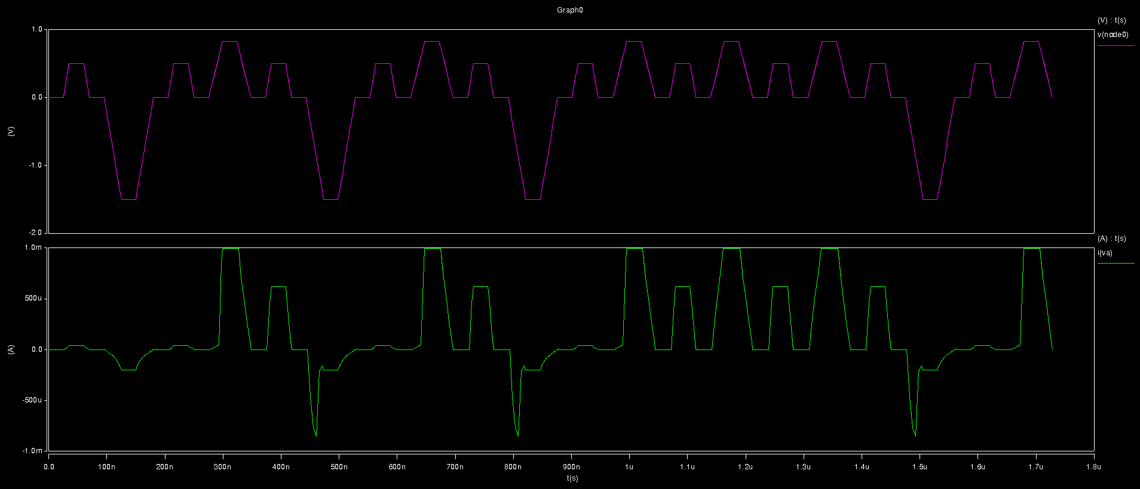

Set Voltage =0.82V, Reset Voltage =-1.5V

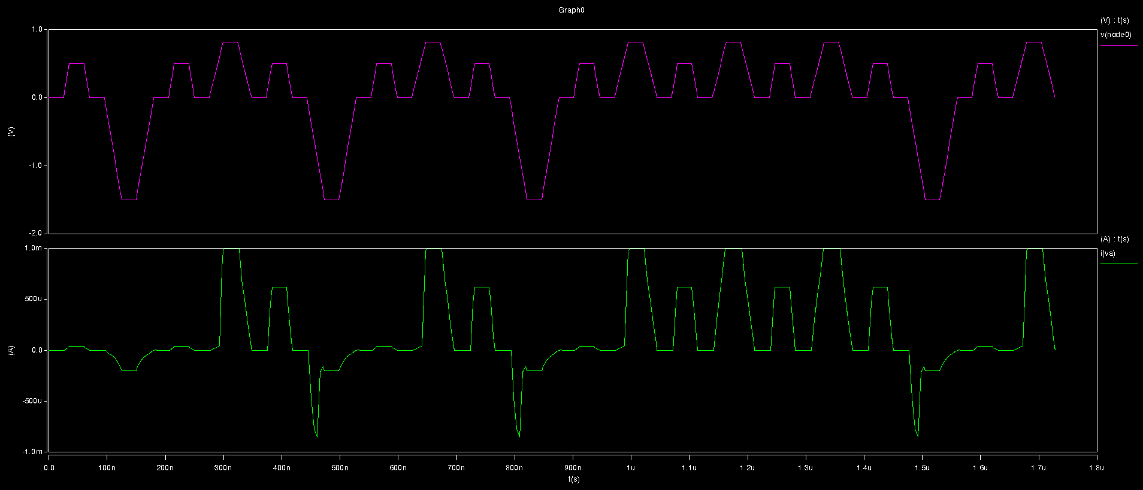

Set Voltage =0.81V, Reset Voltage =-1.5V

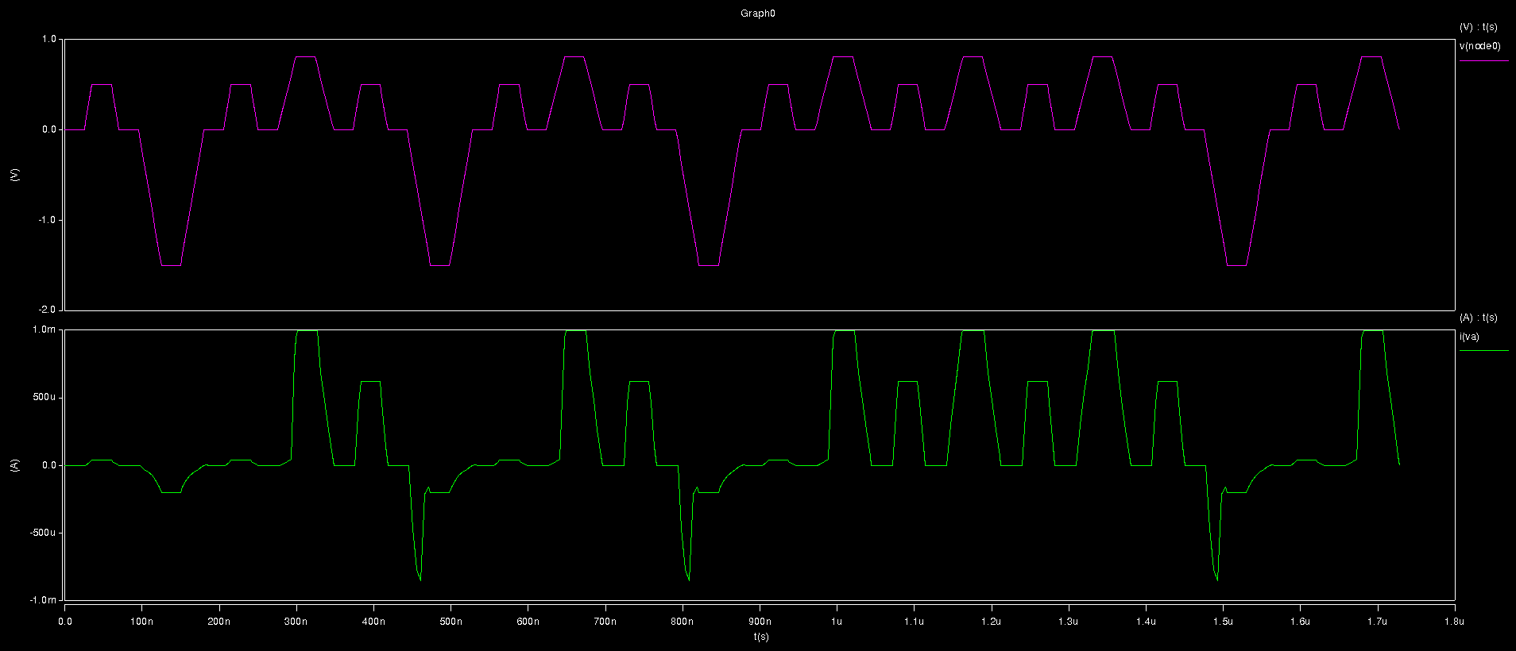

Set Voltage =0.8V, Reset Voltage =-1.5V

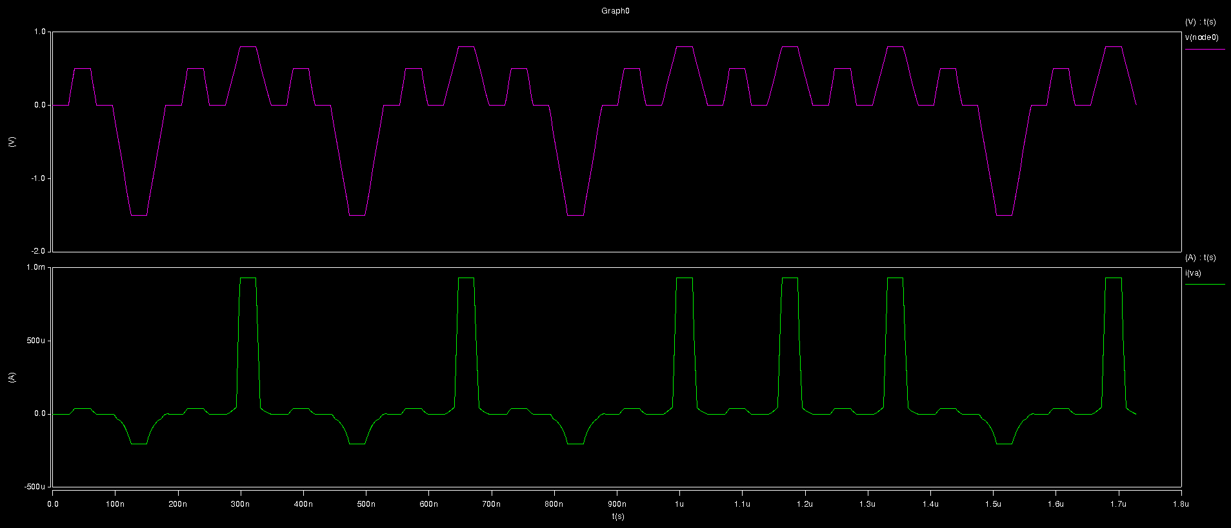

Set Voltage =0.79V, Reset Voltage =-1.5V

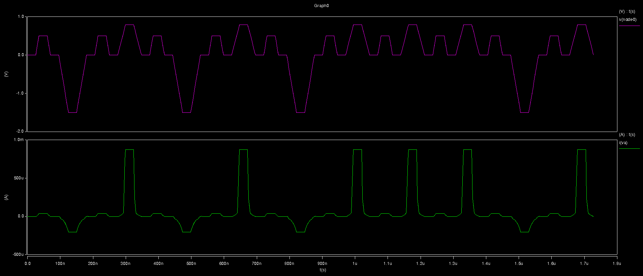

Set Voltage =0.78V, Reset Voltage =-1.5V

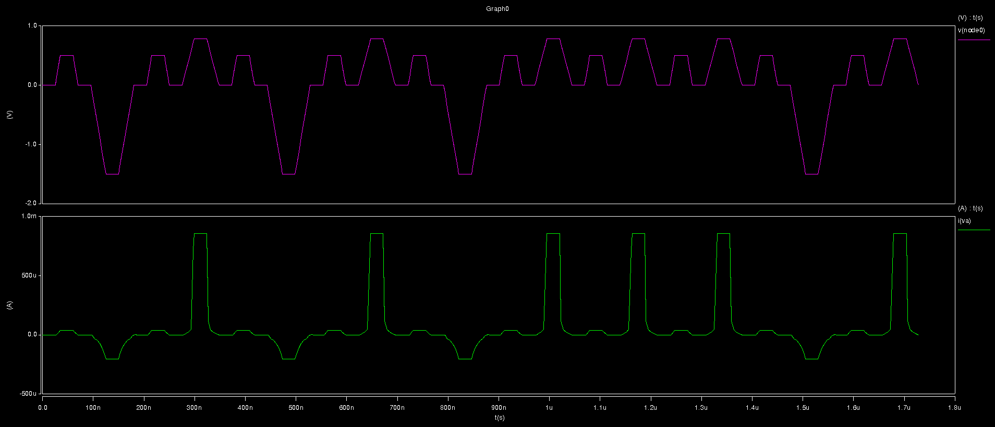

Set Voltage =1.2V, Reset Voltage =-1.4V

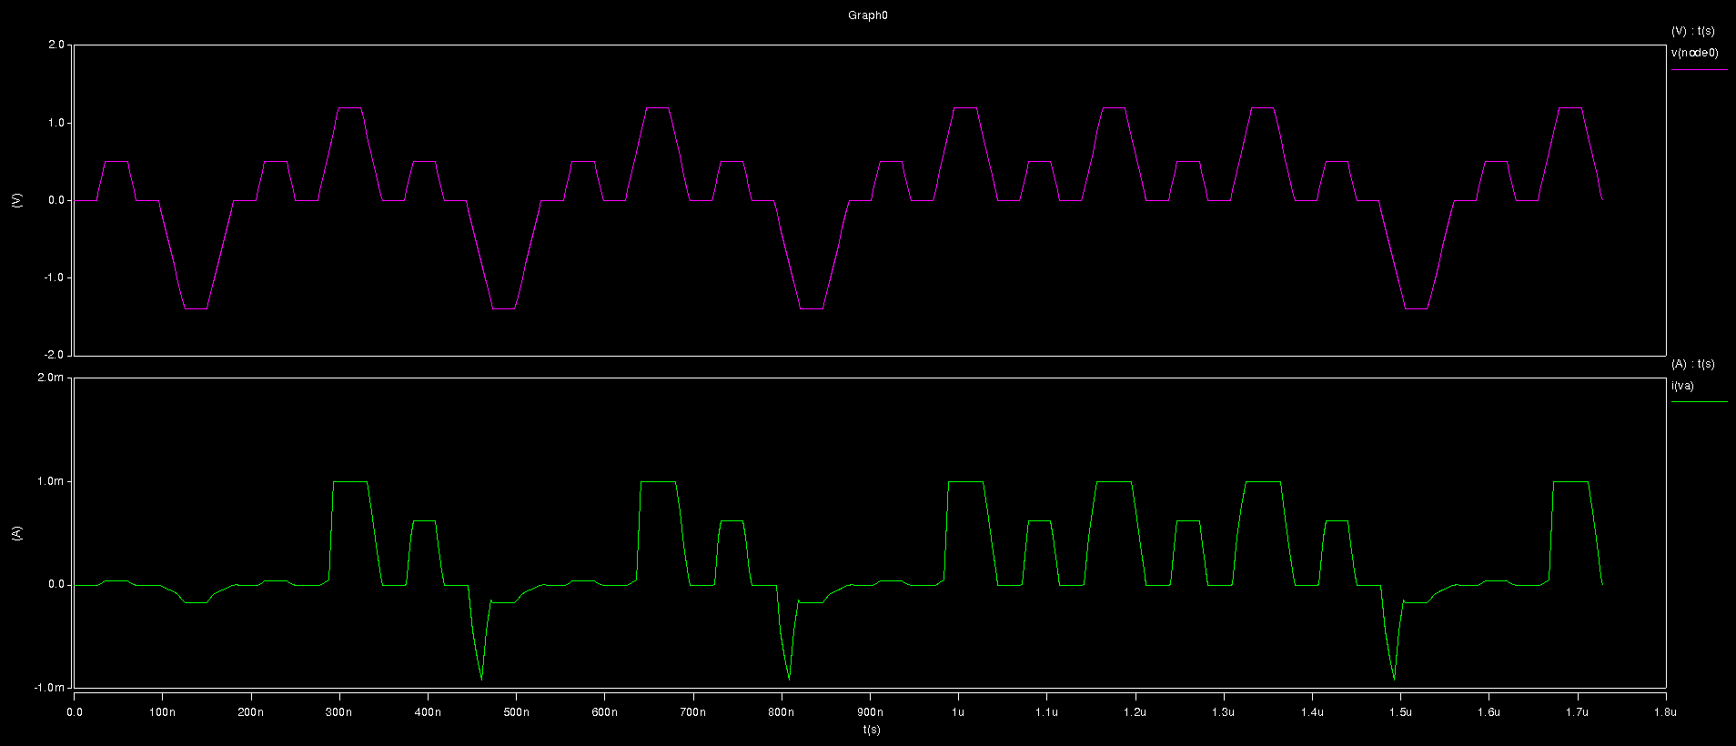

Set Voltage =1.2V, Reset Voltage =-1.3V

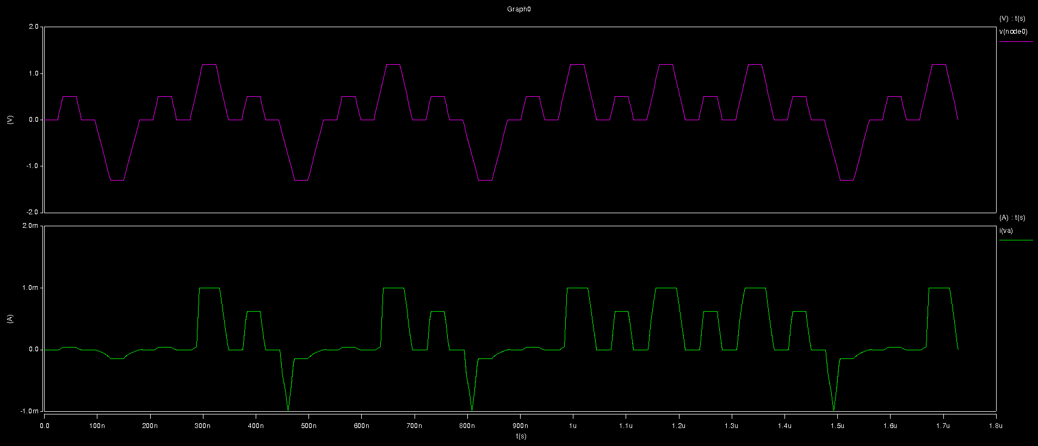

Set Voltage =1.2V, Reset Voltage =-1.24V

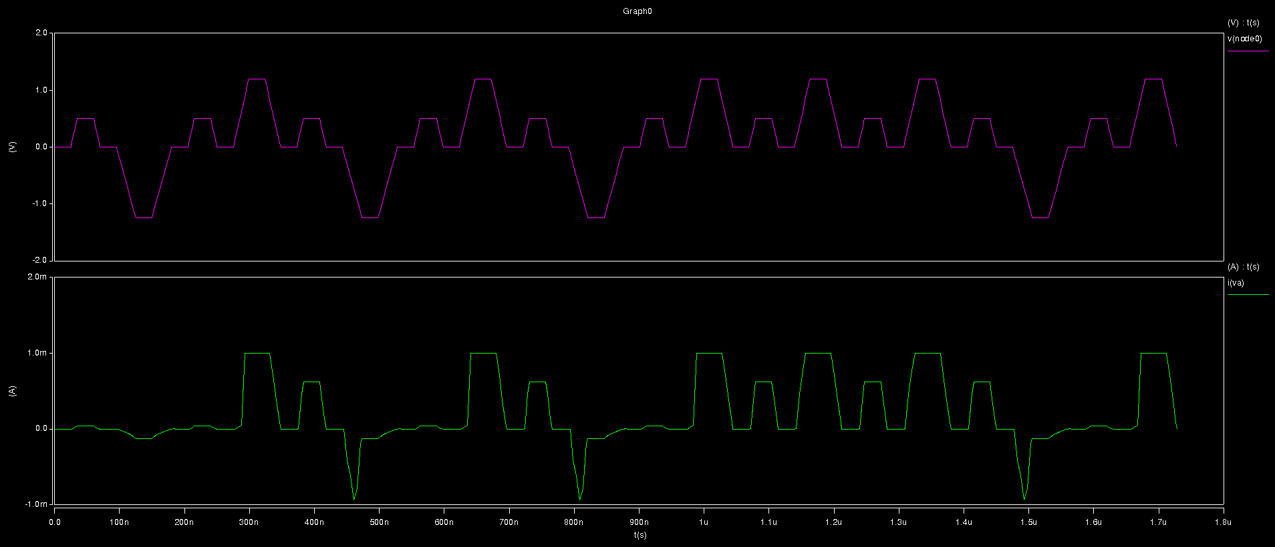

Set Voltage =1.2V, Reset Voltage =-1.23V

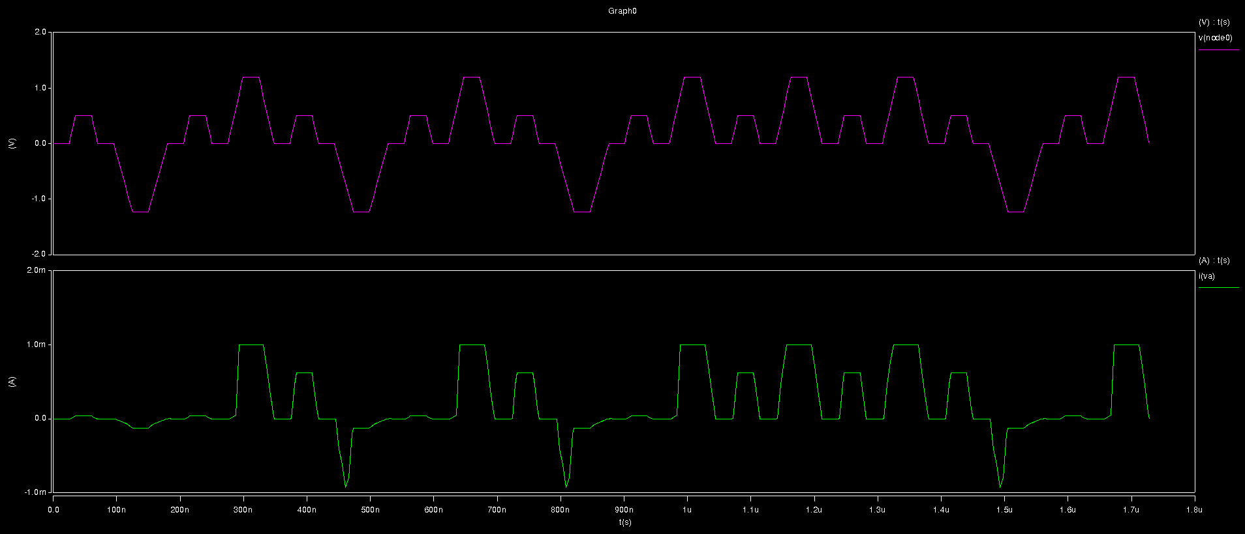

Set Voltage =1.2V, Reset Voltage =-1.22V

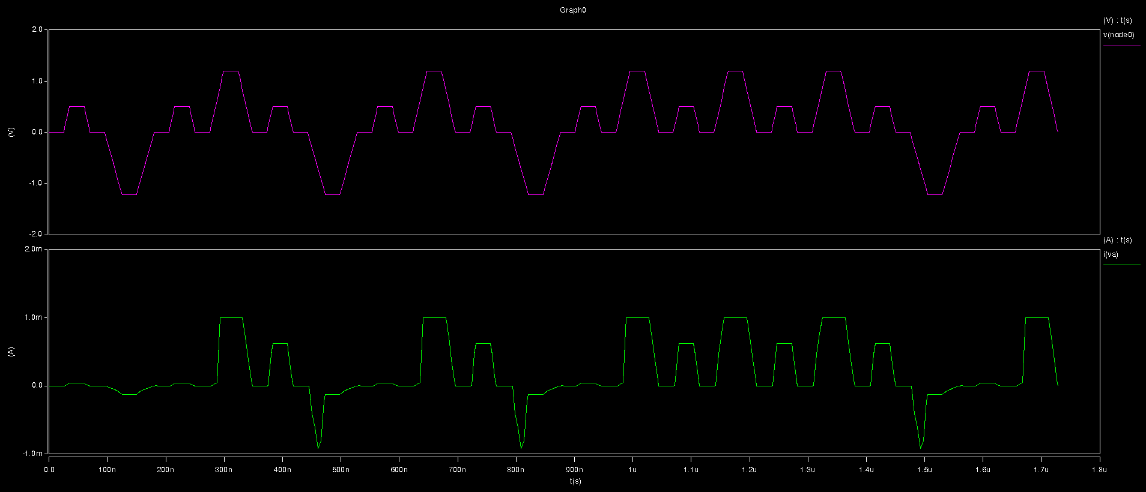

Set Voltage =1.2V, Reset Voltage =-1.21V

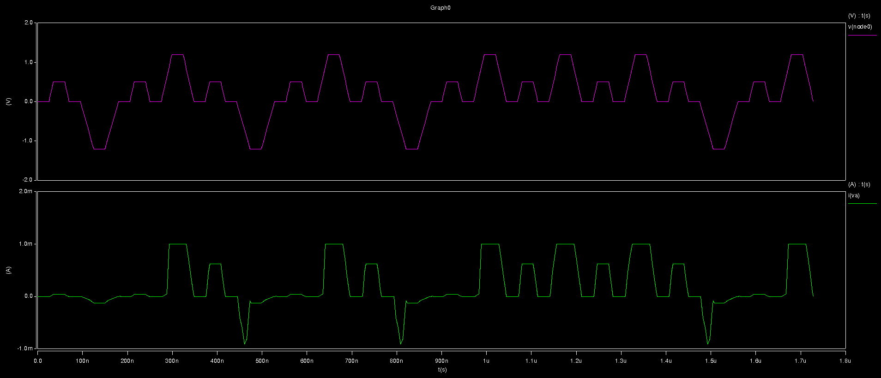

Set Voltage =1.2V, Reset Voltage =-1.2V

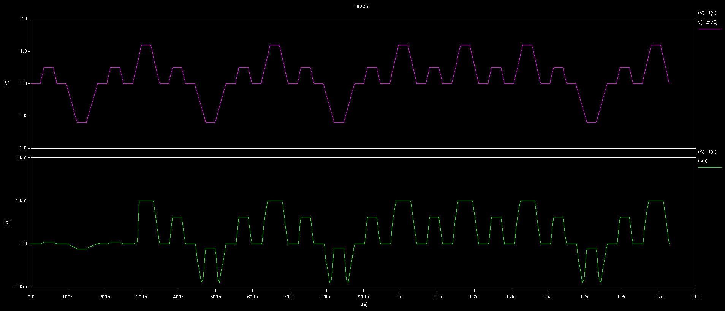

Set Voltage =1.2V, Reset Voltage =-1.19V

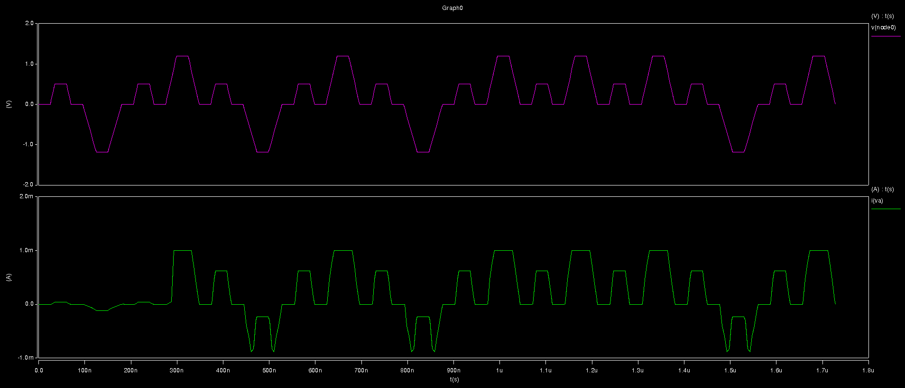

Set Voltage =1.2V, Reset Voltage =-1.18V

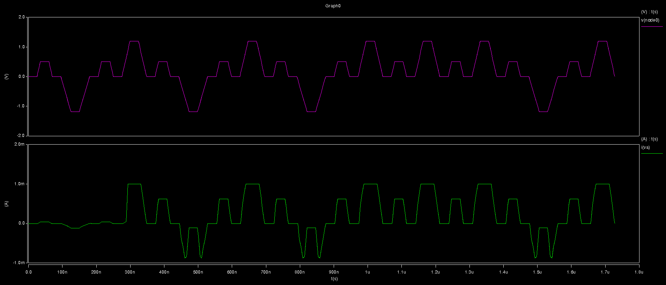

Set Voltage =1.2V, Reset Voltage =-1.1V

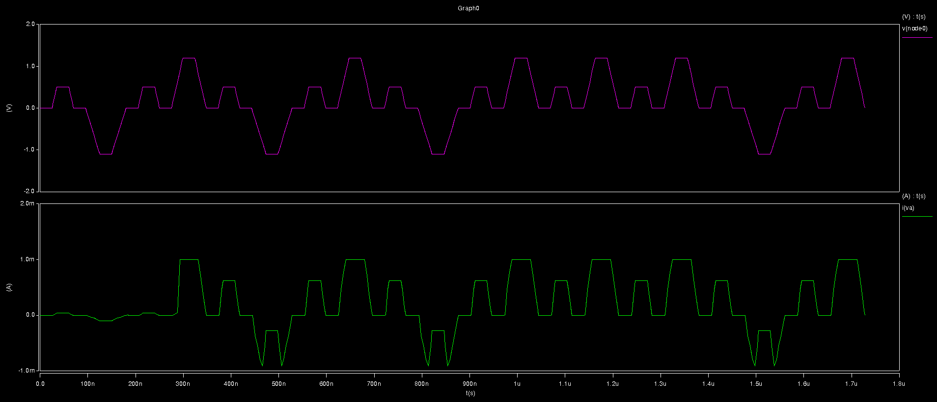

Set Voltage =1.2V, Reset Voltage =-1V

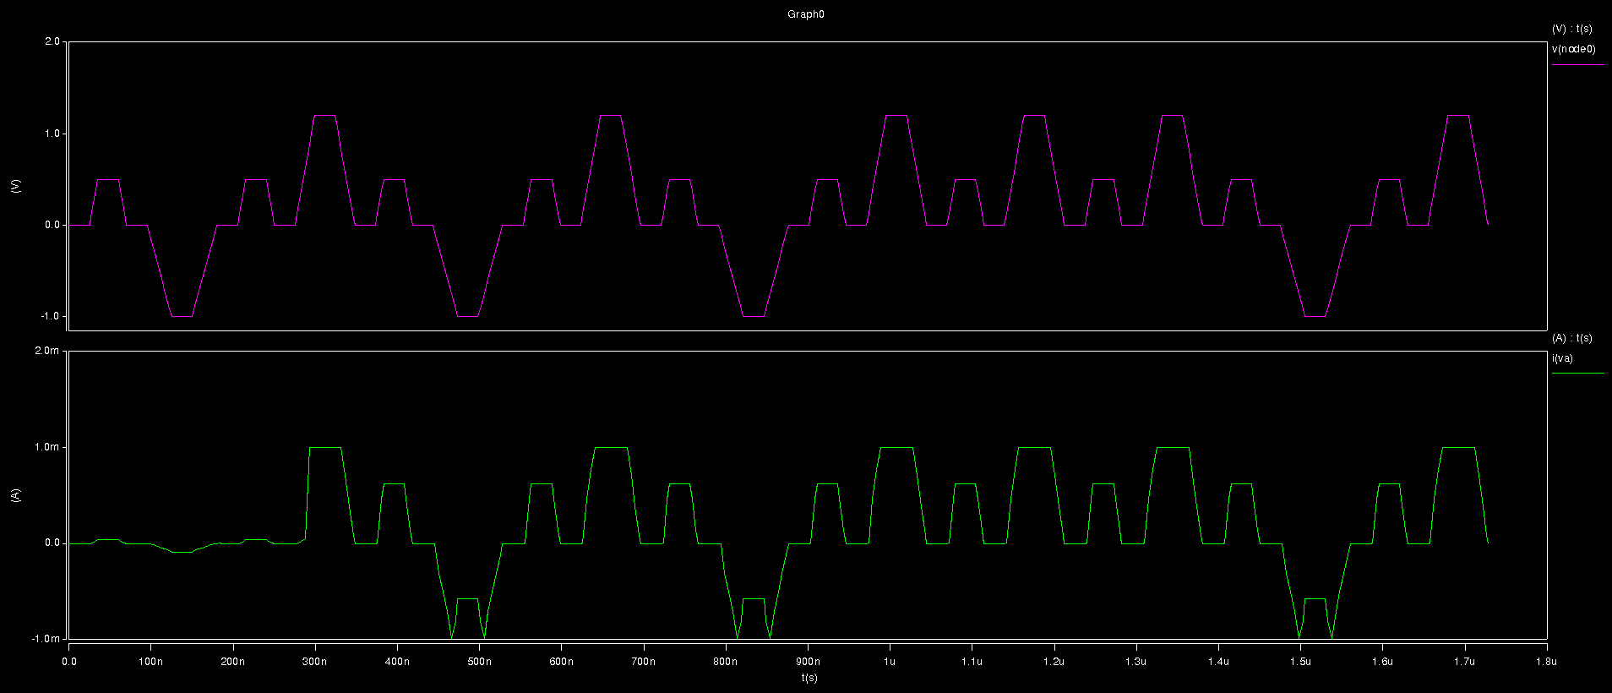

Pulse time=0.25ns

Ramp up/down

Set:24ns

Reset:30ns

Read:10ns

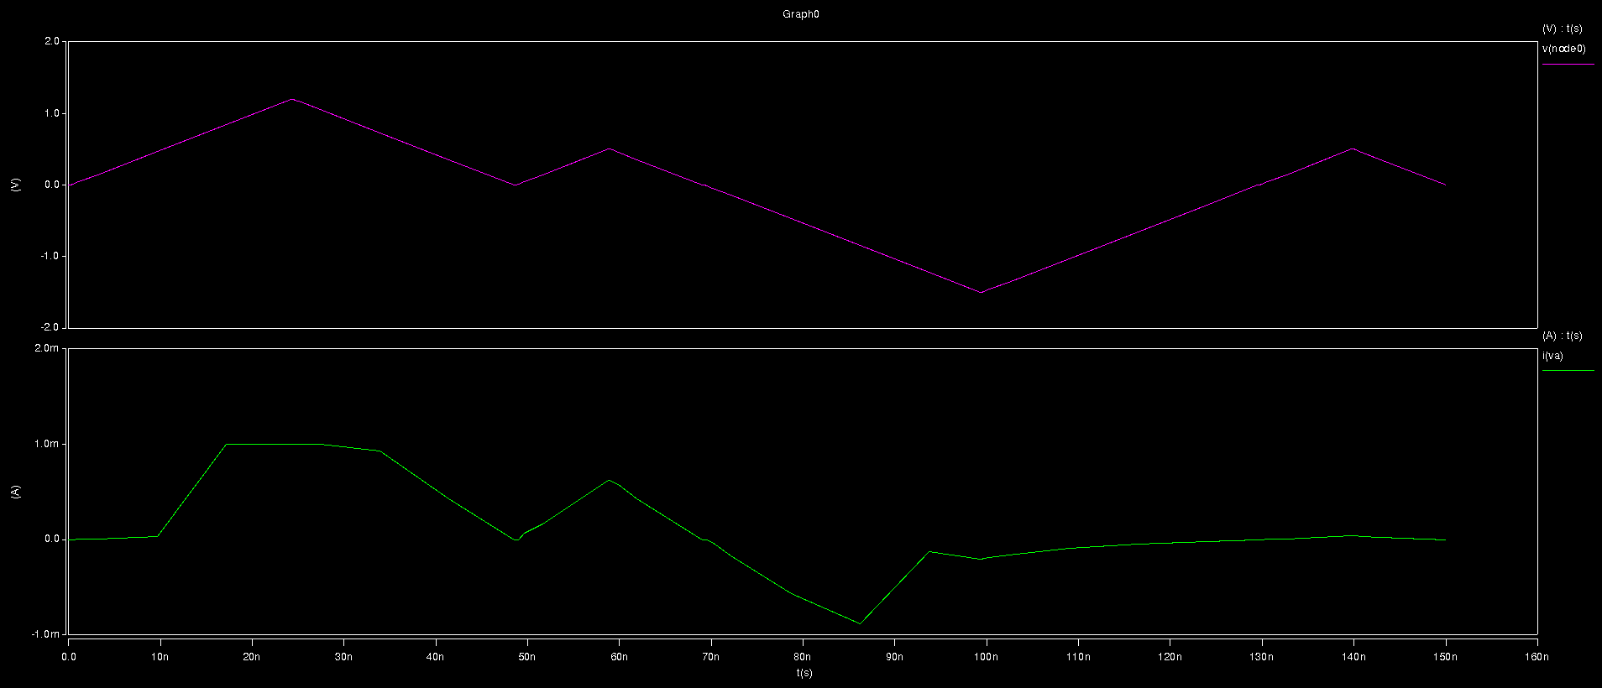

Pulse time=250ns

Ramp up/down

Set:24ns

Reset:30ns

Read:10ns

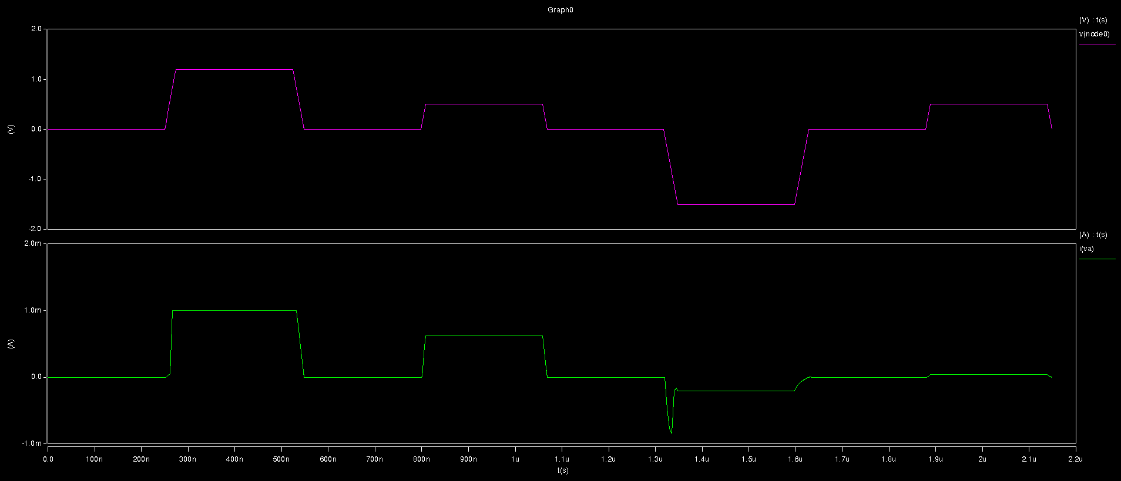

Pulse time=25ns

Ramp up/down

Set:2.4ns

Reset:3ns

Read:1ns

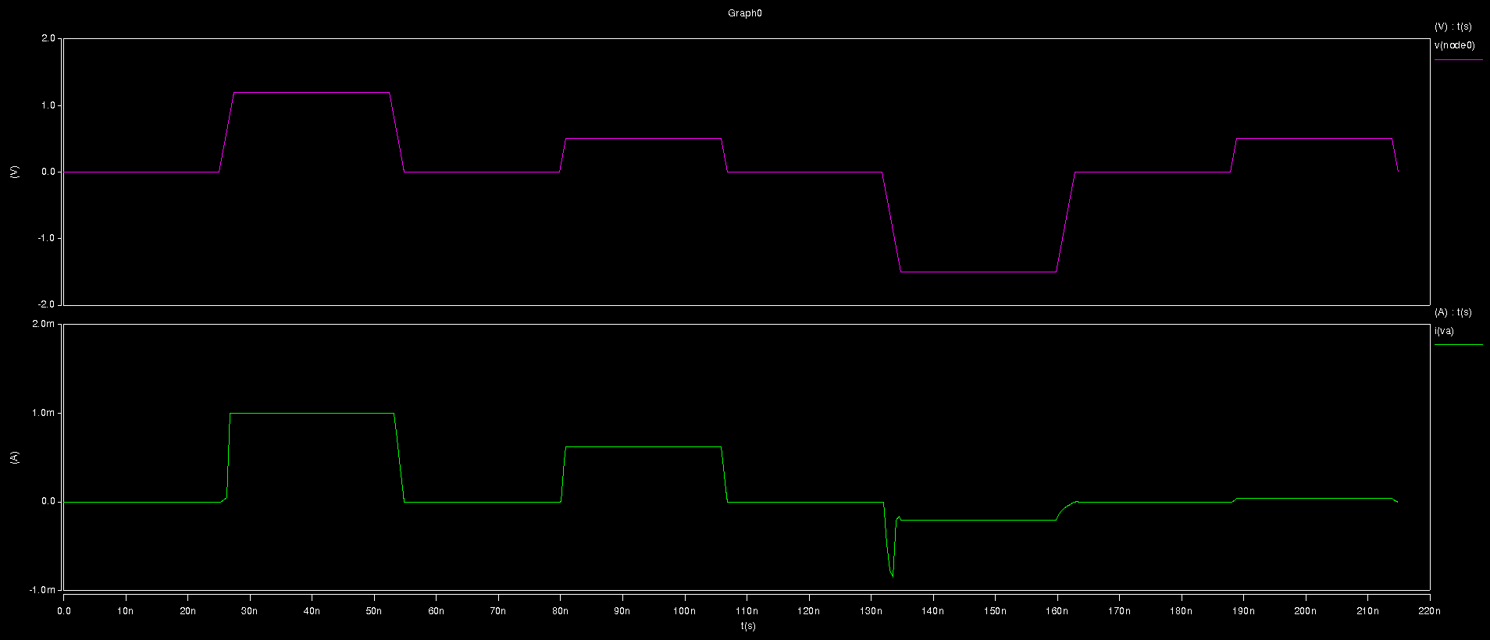

Pulse time=25ns

Ramp up/down

Set:240ns

Reset:300ns

Read:100ns

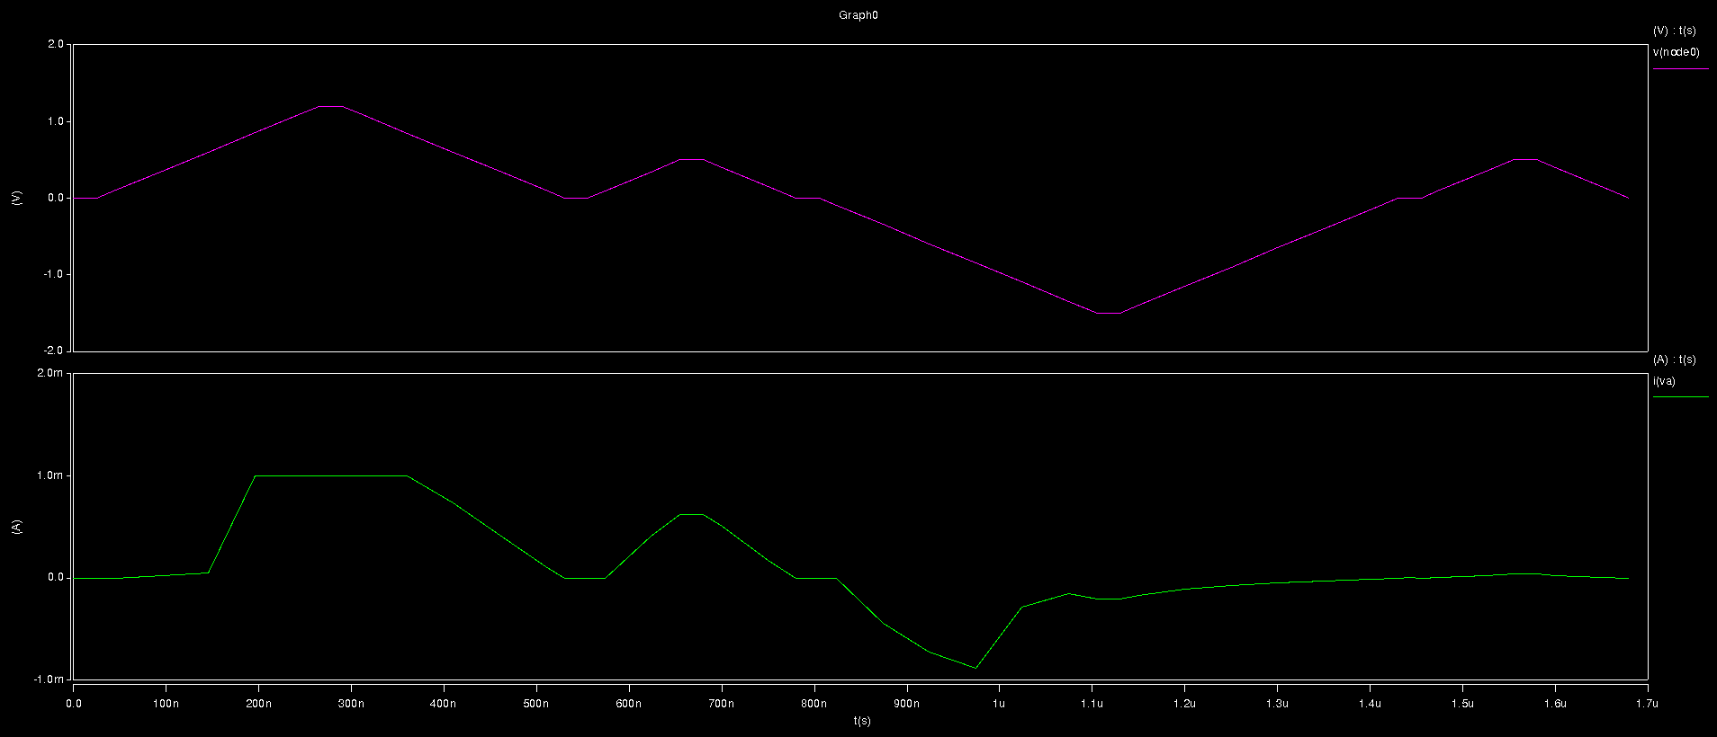

SIN(0.1GHz)

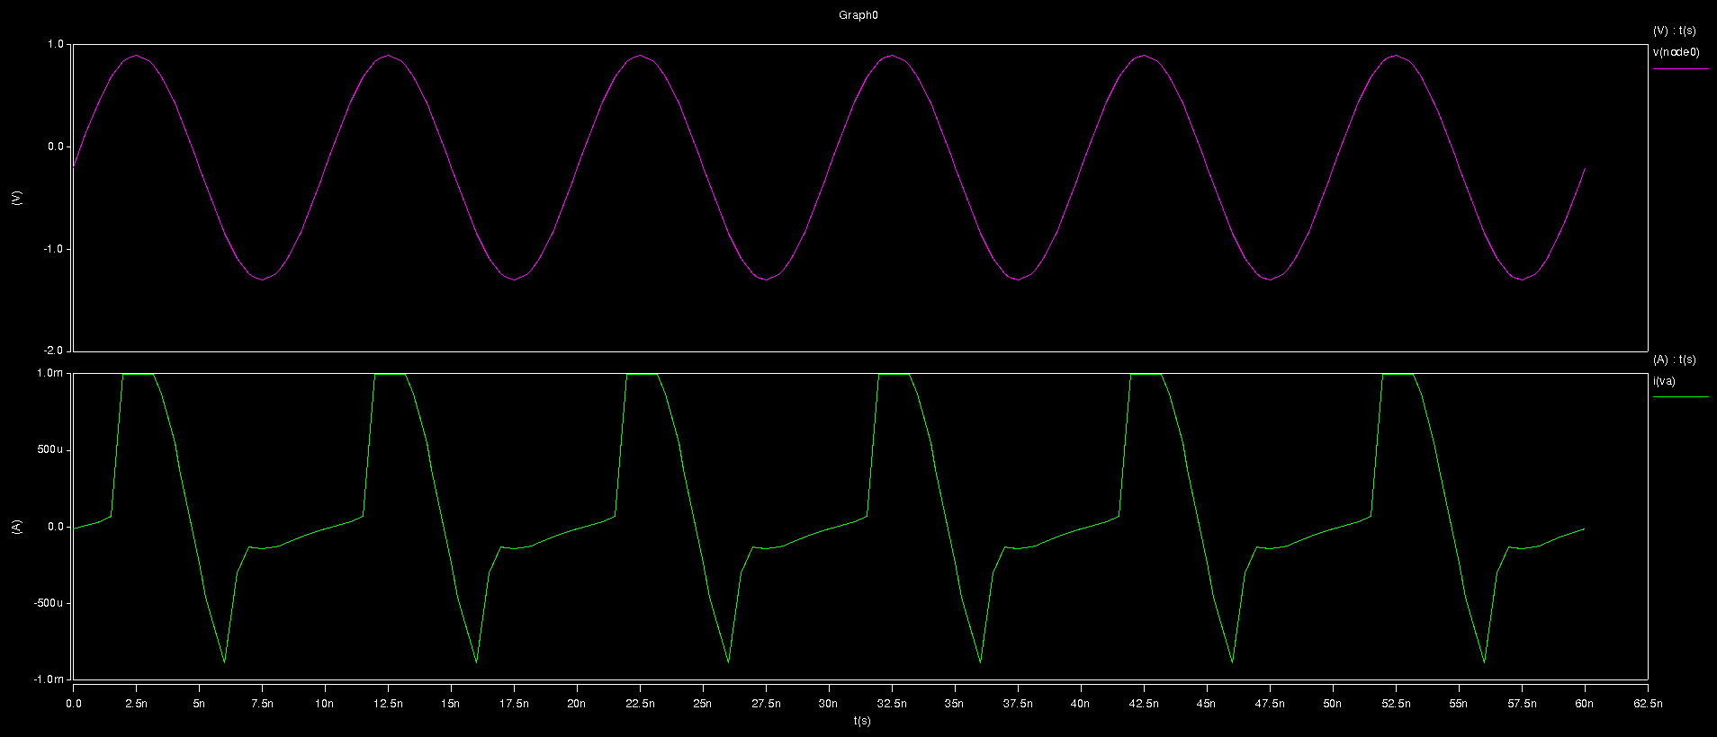

1T1R

Pulse time: 24ns

Ramp up/down: 23ns

Set→Read→Reset→Read

Transient time: 399ns

ML model

\*\*\*\*\*\* Runtime Statistics (seconds) \*\*\*\*\*\*

analysis time # points tot. iter conv.iter

op point 0.66 1 15585

transient 0.04 400 1269 294 rev= 73

readin 0.18

errchk 0.03

setup 0.00

output 0.00

Physical model

\*\*\*\*\*\* Runtime Statistics (seconds) \*\*\*\*\*\*

analysis time # points tot. iter conv.iter

op point 0.00 1 3

transient 0.02 400 990 457 rev= 5

readin 0.17

errchk 0.03

setup 0.00

output 0.00